Procedure for finding the curve of a robot movement

Background: In order to program the robot to drive a curve, you need 2 things. First is the angle you want the robot to move through. Second is the radius of the curve.

We use Autocad inventor with a 3D model of the field. The robot is modeled as an 18” cube.

1. Place the robot where you want the movement to start.
2. Place a second robot about where you want the curve to end.
3. Constrain the angle between the two robots to what you want. Select the work planes in the robots to add the angle constraint.  
   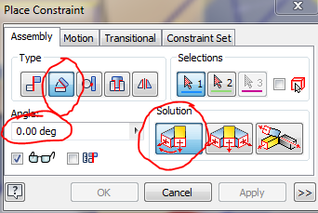
4. Now position the second robot as exactly as you can.
5. Measure between the holes in the center of the robots to get the distance between them.
6. Plug the angle and the distance into the robot curve spreadsheet. That will calculate the radius in inches for the curve.
7. Now edit sketch2 in the model.
8. Project the center hole in both robots to the sketch.
9. Add a 3 point arc. The first point is the projected center hole. The second point is the center of the other projected hole. Type in the radius of the curve and the curve will show up.
10. Add a center point arc to track the location of the corners of the robot to make sure it is not hitting anything. The first point is the center of the arc you added in the step above. The other 2 points are the corners of the 2 robots.